**Freelancer**

The URL is <http://64.227.39.186:31639/>

From source code, I was able to see portfolio.php?id=3

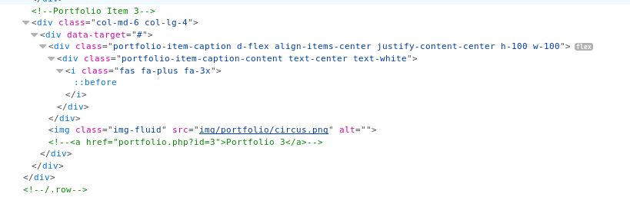

With this portfolio, I ran a SQL-map command in Kali

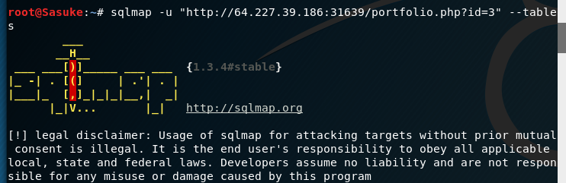

Next, I was able to see a table called “safeadmin”

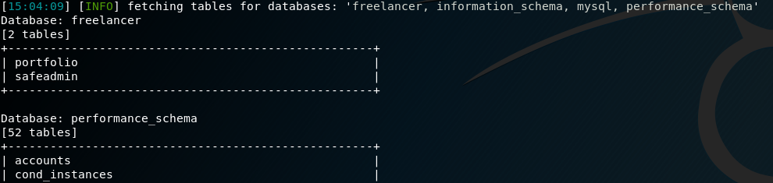

Next, we dump that table using the command:

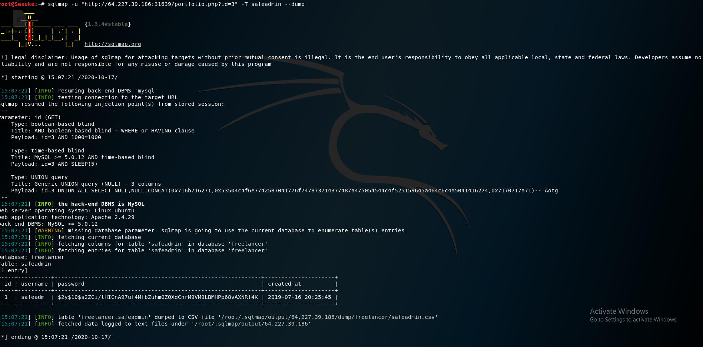

Now, I can see the password is a hash that looks almost uncrackable

From the tables earlier, there was one called administrat

So next, I can use a command to find all php words in that database administrat

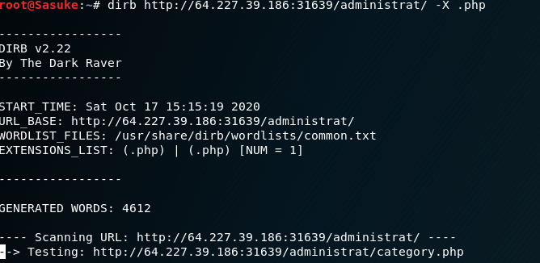

I found an index.php, logout.php, panel.php

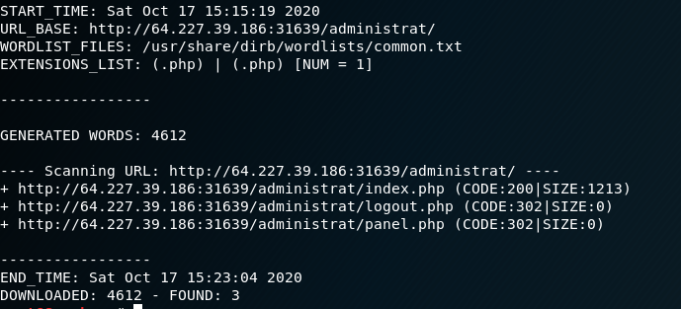

Panel sounded the most interesting to me, so I ran SQL-map to see if any files are stored in that database

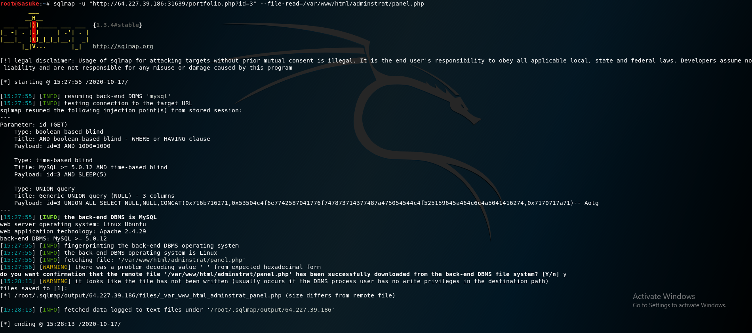

Now that I have the remote file stored locally, I can search for it in the command line



Now entering that command, I found the flag below!

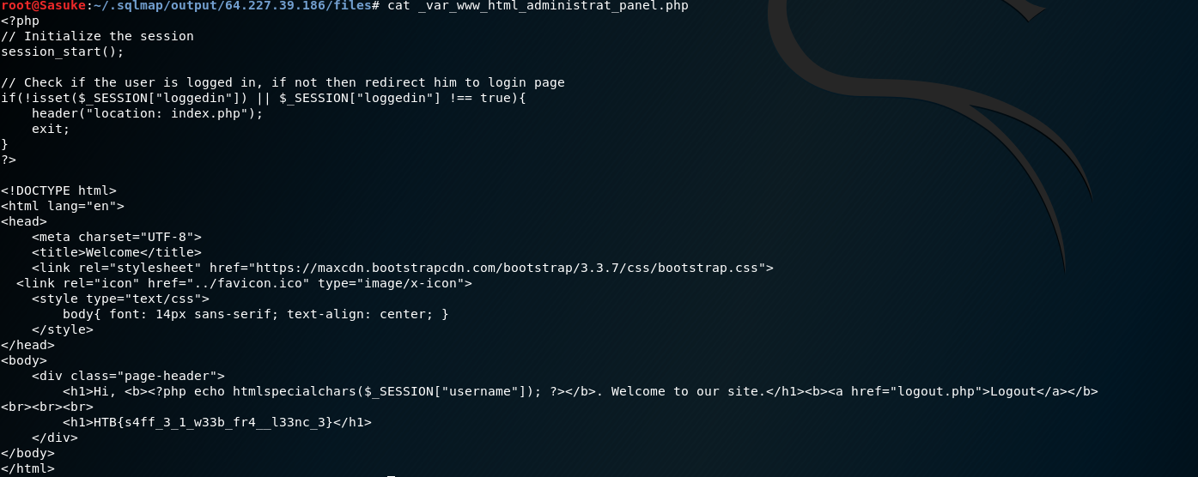

Success!

